Pre-Phase A: Concept Studies

Brandon Hickey

9/22/2023

Following: <https://www.eng.auburn.edu/~dbeale/ESMDCourse/Chapter2.htm>

# Purpose

The purpose of this section is to first create a list of ideas and concepts that satisfy the desired outcome and mission objectives. This will then be used in the 11 SE functions to derive a series of potential solutions.

# Systems Engineering Functions

Here I will attempt to go through each function and attempt to perform them at this stage.

## SE Function 1: Mission Objectives and Constraints

The goal of this project is to develop, design, and test a 3D printed remote-controlled aircraft capable of decent flight time and potential for payload. Due to the nature of the project, goals and requirements at this stage are ambiguous and lack many hard-set constraints. I will go through and list the current objectives and constraints and attempt to provide a range of required performance to then use moving forward in Phase A – Concept and Technology Development

## SE Function 2: Derived Requirements Development

### Project Objectives and Constraints List

* The aircraft frame should be made from a 3D printable material. Using personal printers, individual part sizes should not exceed 200mm x 200mm x 200mm. This is to limit the potential for print failure as the larger pieces result in more time to print. Also, as prints move from the center of the build plate, issues arising from leveling and bed adhesion become more common.
* The aircraft wingspan should be less than 1500mm. This is a personal decision, but I believe that increasing the aircraft leads to higher costs in terms of material and electronics and will become more costly to continue the project should multiple failures occur during testing phases. The minimum wingspan size will likely be dictated by the desired performance of the aircraft in terms of payload size and aircraft weight.
* The vehicle must function on either 2S or 3S lipo batteries. I would prefer to be able to utilize a 2S due to the lighter weight. I, however, understand that given the weight of the aircraft I may need a higher voltage.
* Looking at some forums of RC Plane flyers, for a beginner flyer I am looking at a cruising speed of roughly 20-30 mph or 9 – 13.5 m/s. This should provide a low minimum runway distance. The slow speed should also ensure that I am able to watch and critique the performance of the aircraft during passes.
* So, I do not have any desired weight limits, however I believe something less than 1,000 grams would be good in terms of manufacturing time. It will give me a targeted motor thrust output. I will look for a Thrust to weight ratio of between 0.2 and 0.5. At my limit, that would require a motor thrust between 200 and 500 grams.
* I am looking for a flight time of at least 10 minutes, this is a minimum, but my preferred range would be around 20 minutes.
* The aircraft should be operable with a payload that will include a more advanced flight controller such as a Navio2. While I do not have the exact weight of the flight controller currently, I would estimate it will be no more than 300 grams.

### Identified Objectives and Constraints

* Made from 3D Printed Material.
* Individually printed pieces should not exceed 200mm x 200mm x 200mm.
* Aircraft wingspan to not exceed 1500mm.
* Electrical voltage will be either 2S or 3S Li-Po
* Aircraft Cruising speed: 9 – 13.5 m/s
* Vehicle weight less than 1,000 grams
* Thrust to weight ratio: 0.2 – 0.5.
* Motor Thrust: 200 – 500 grams
* Capable of flying for at least 10 minutes, 20 is preferred.
* Capable of carrying an extra 300-gram payload.

## SE Function 3: Architectural Design Development

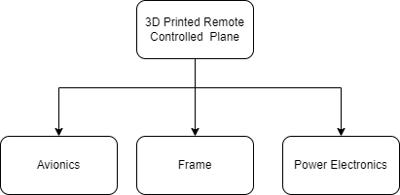

## SE Function 4: Concept of Operation

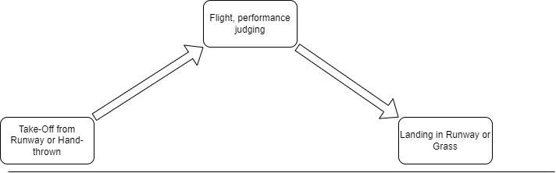

## SE Function 5: Validate and Verify

### Requirements Verification

To ensure we are satisfying our requirements, we will be performing basic calculations and testing to ensure we meet our requirements. This can include doing basic thrust and power calculations with a potential motor/prop combination to provide the desired T/W ratio as well as calculating our aircraft dimensions based on weight and desired speed.

### Systems Verification

We will be performing testing throughout development to ensure system operates safely and as expected. Such areas will include testing control surface directions and electronics wiring before the vehicle even approaches the runway.

### System Validation

Ensure that we are designing and developing according to the mission objectives and staying within our constraints.

## SE Function 6:

Not Completed, used later in Phase B.

## SE Function 7: Mission environment

Identify all environmental factors and potential concerns and exposures. For our aircraft we expect low winds (less than 10 mph), minimal weather.

## SE Function 8: Technical Resource Budget Tracking

Expected Budgets we plan to track during the project:

* Mass budget, this will help us keep track of the breakdown of object weights and where we might be able to trim potential issues.
* Cost Budget, keeping track of costs is important.
* Power Budget, this might be good to keep track of our power consumption to give a good breakdown of flight time estimation.

## SE Function 9: Risk Management

We will perform the following in the project.

* Seek and Identify risks.
* Determine risk severity and effect.
* Develop methods of risk mitigation

## SE Function 10: Configuration Management and Documentation

All content except Fusion360 files will be stored in GitHub. Project management will also be done through GitHub to maintain traceability. If Fusion360 files are added, they can be uploaded daily with provided changes.

## SE Function 11: System Milestone Reviews and Reports

As I am the stakeholder, my reviews are kind of to myself? I can mark milestones using GitHub to identify major areas of the project such as finishing phases and scheduled testing dates.